New in MetaBase Version 2.0

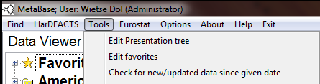

Edit favorites:
In MetaBase 2.0 the first node in the “Data Viewer” tab sheet is the “Favorites” node. At this node you can add your own tree of data/information you like to have close at hand (i.e. you will use frequently and putting them in the Favorites will make it easier to find and use them).
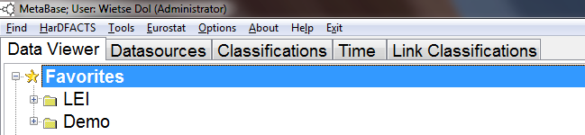
Pressing “Tools” and “Edit favorites” will open the “Edit user favorites” window (see below, you can also double click on the “Favorites” node in the tree). The left tree contains your current Favorites tree and the right tree is the official MetaBase tree. You can browse through the MetaBase (right) tree and then drag and drop the selected node (and its children) to the root of the Favorites (left) tree or drag and drop it to a folder node. You can also click with the right mouse on the right tree and then select “Add to root” to add the selected MetaBase node (and its children) to the root of the Favorites tree. The “Add to node” will add the selected node (and children) to the currently selected Favorites node (in our example the “Demo” folder).
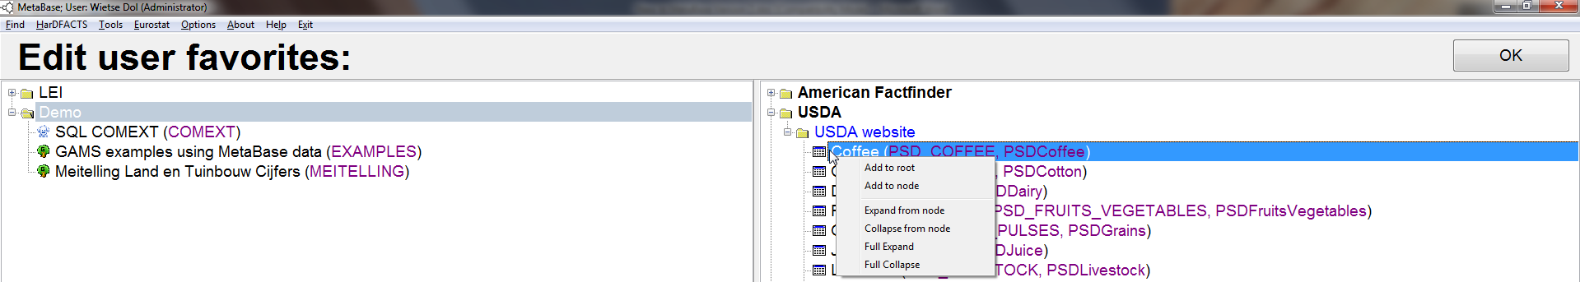
If you right click on the Favorites tree a popup menu will be shown and with this popup you can:
Add root heading: add a root folder to the Favorites tree.
Add heading: add a subfolder to the currently selected node (in example below the “LEI” folder).
Delete node: delete a Favorites node (and its children)
Delete Children: delete the children of the selected Favorites node
Move up: move the selected node one up in the parent tree
Move down: move the selected node one down in the parent node tree
Move to root: Move the selected node to a root node
Rename: change the title of the selected node

Note that dragging and dropping nodes from the Favorites tree into the Favorites tree also works (and makes it easy to move nodes in the Favorites tree).

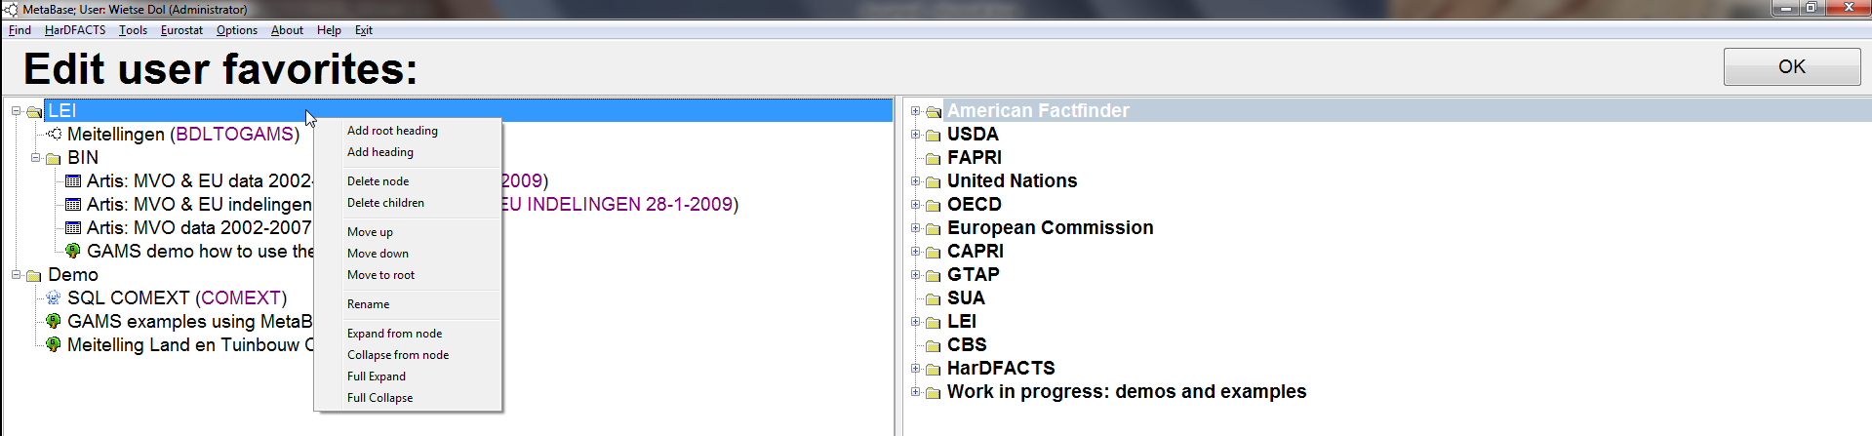
After you have created/updated the Favorites tree you want press the “OK” button to save the tree into the database (i.e. in the Favorites table). Every time you start MetaBase, your Favorites tree will be available to you.

Edit Presentation tree:
For MetaBase administrators (those with admin=1 in the .INI file) it is possible to edit/change the MetaBase tree as it is presented in the “Data Viewer” tab sheet. Click on “Tools” and then “Edit Presentation tree” to get the “Edit MetaBase presentation” window.
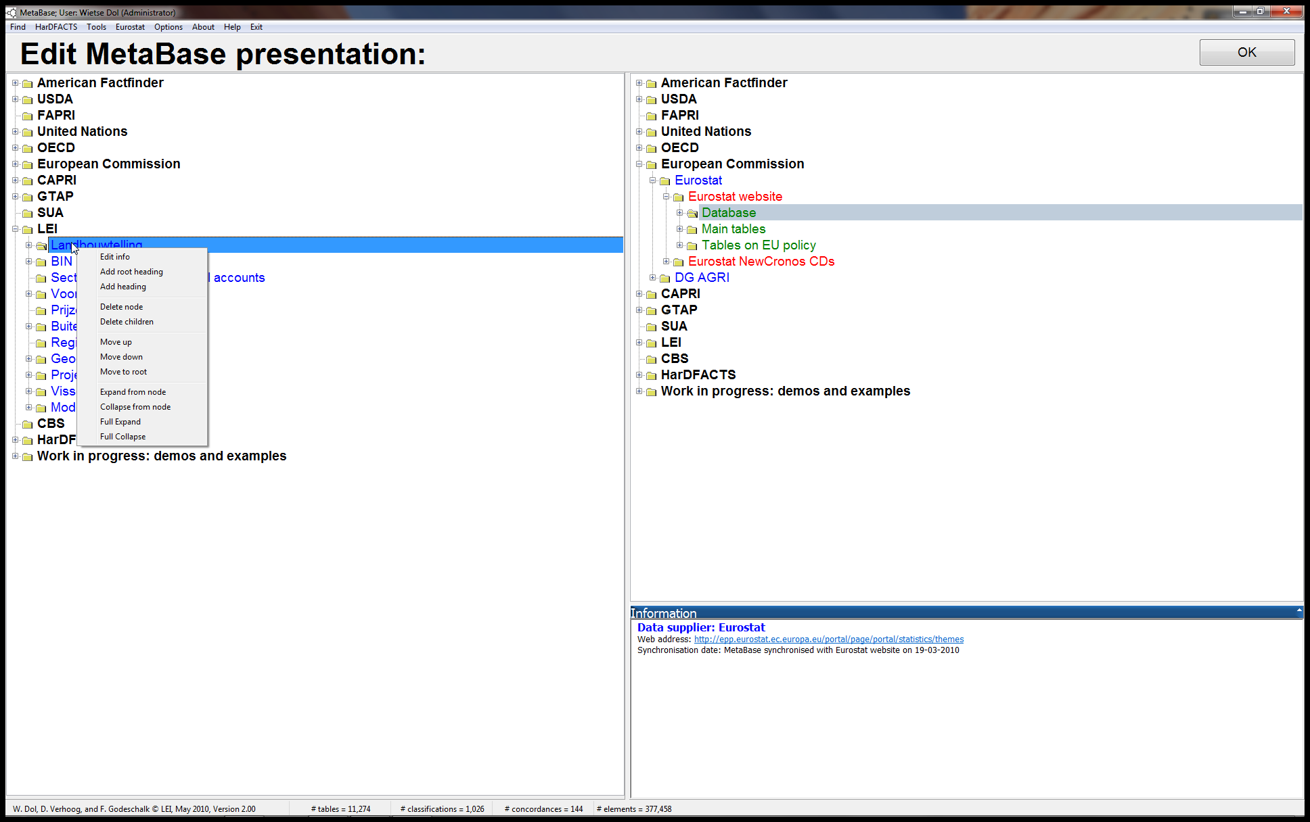
The “Edit MetaBase presentation” window works similar to the “Edit Favorites” window as explained above. The difference between the two windows is that in “Edit MetaBase presentation” you can edit/change the content of the presentation object (this information is stored in the Presentation table in the database). If you right click on one of trees and then select the “Edit info” popup you will be able to edit the presentation object of the selected tree node.
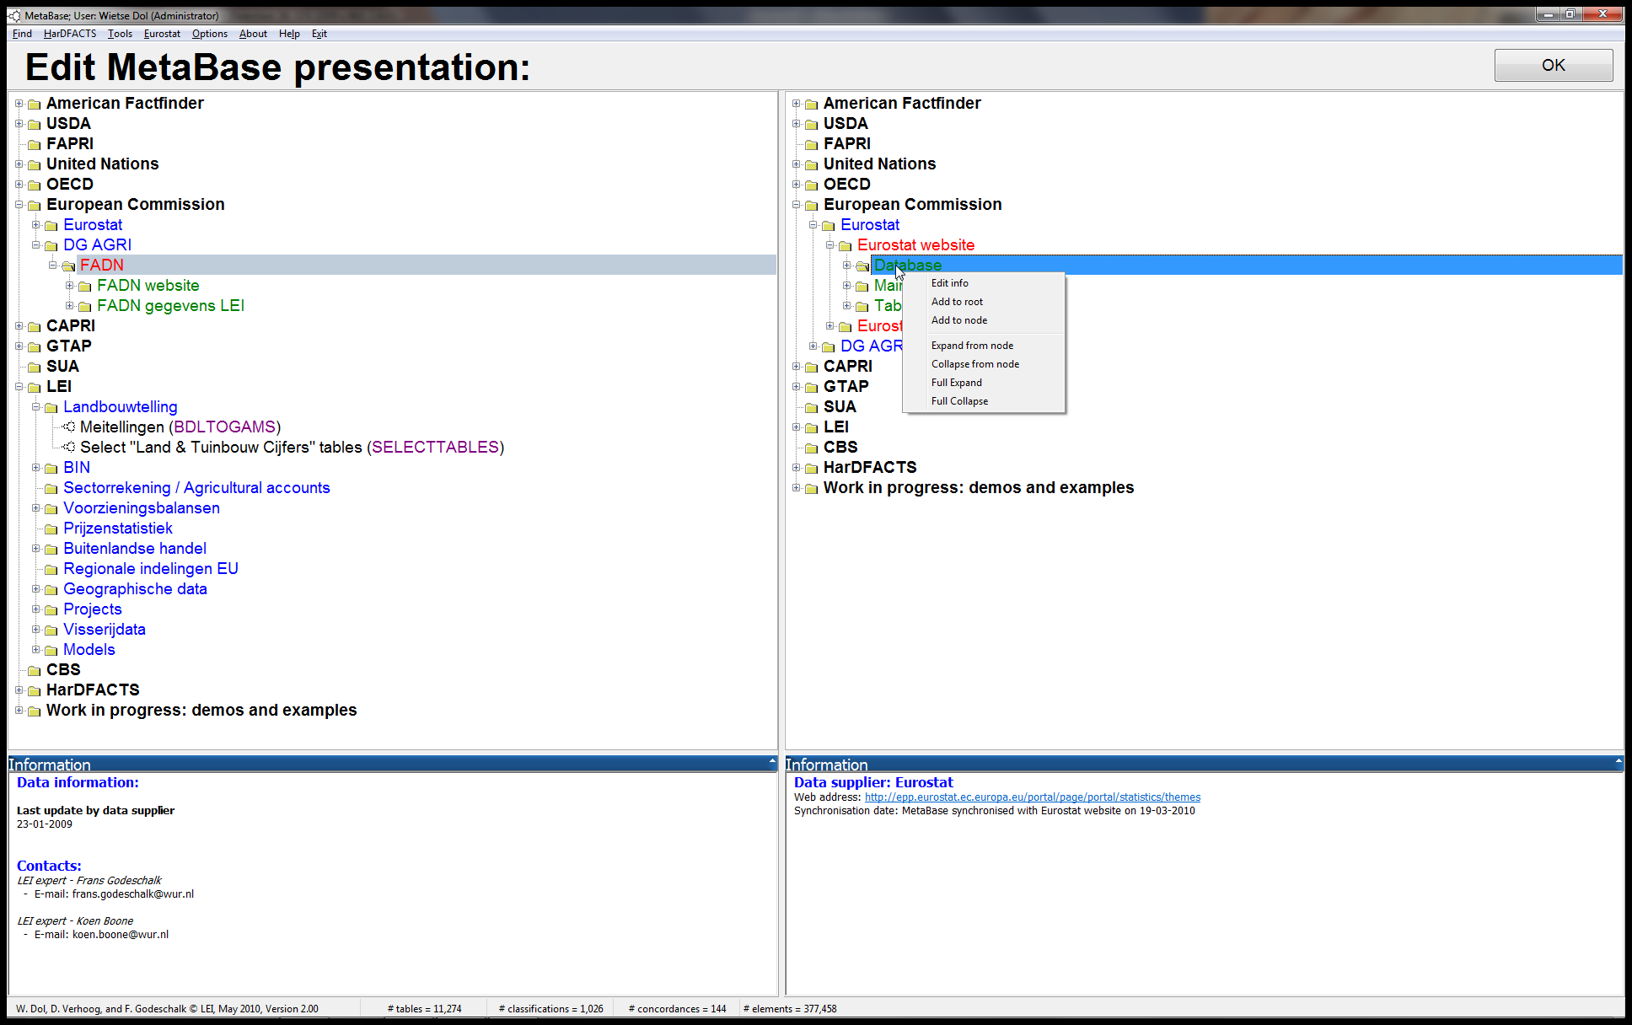
In the two windows below we show/edit the presentation object “DG AGRI” (a folder node) and “Crops products (excluding fruits and vegatables)(annual data)” (a real data table).
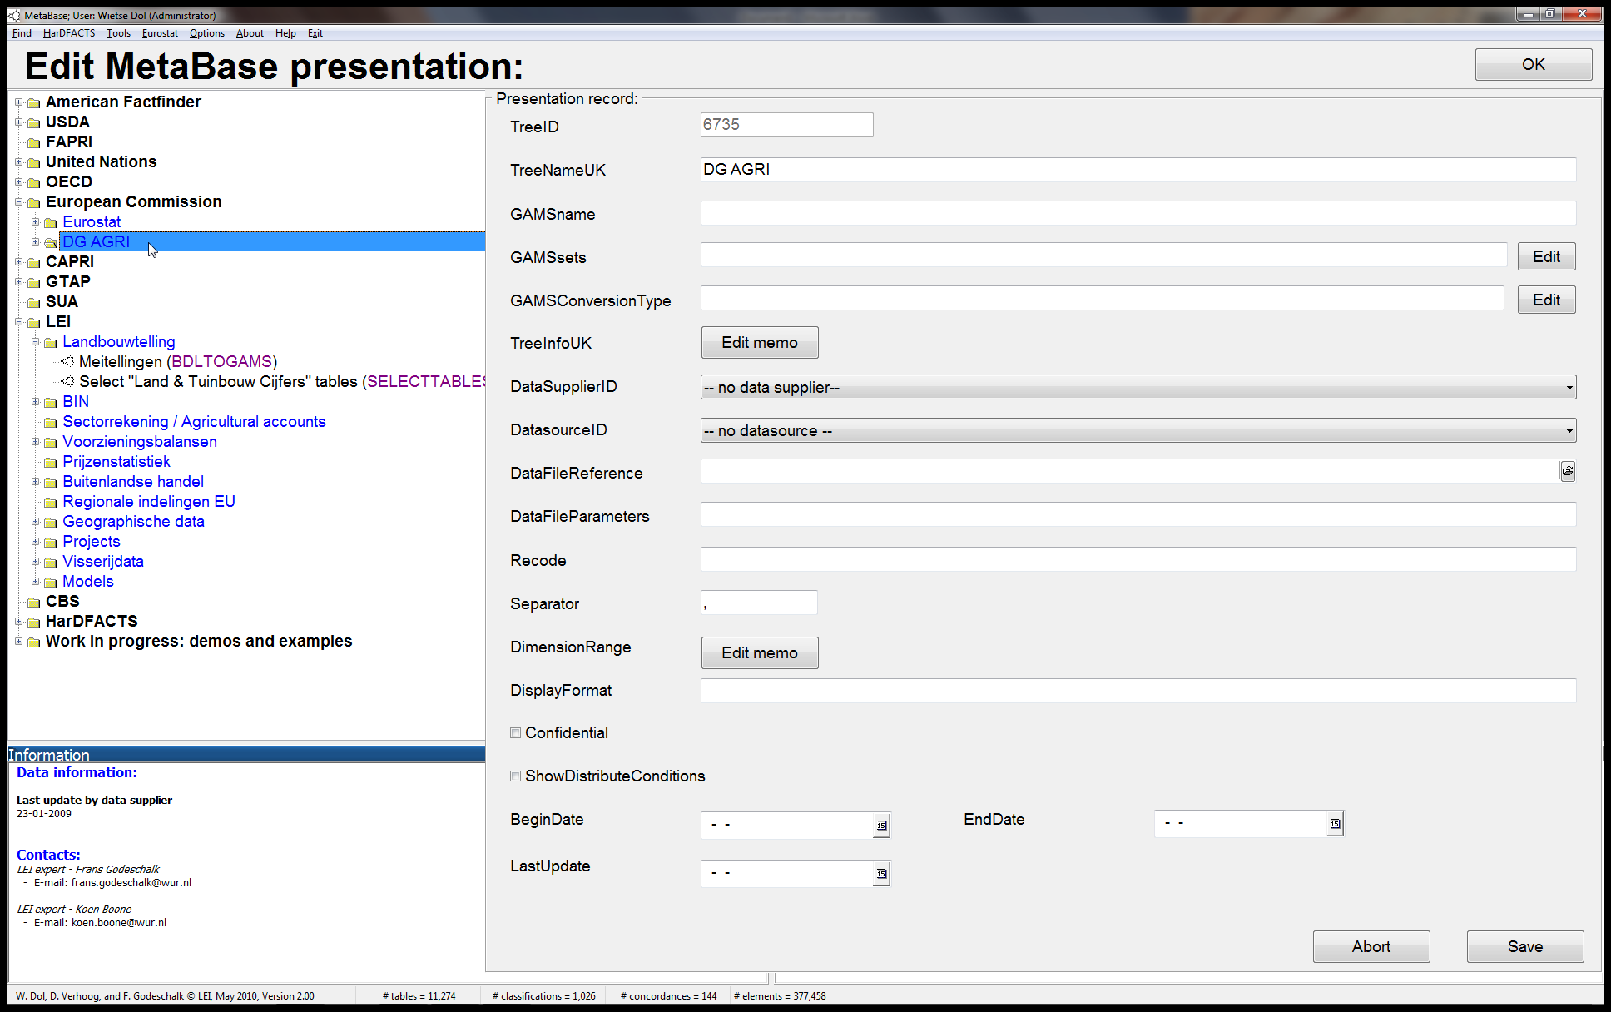
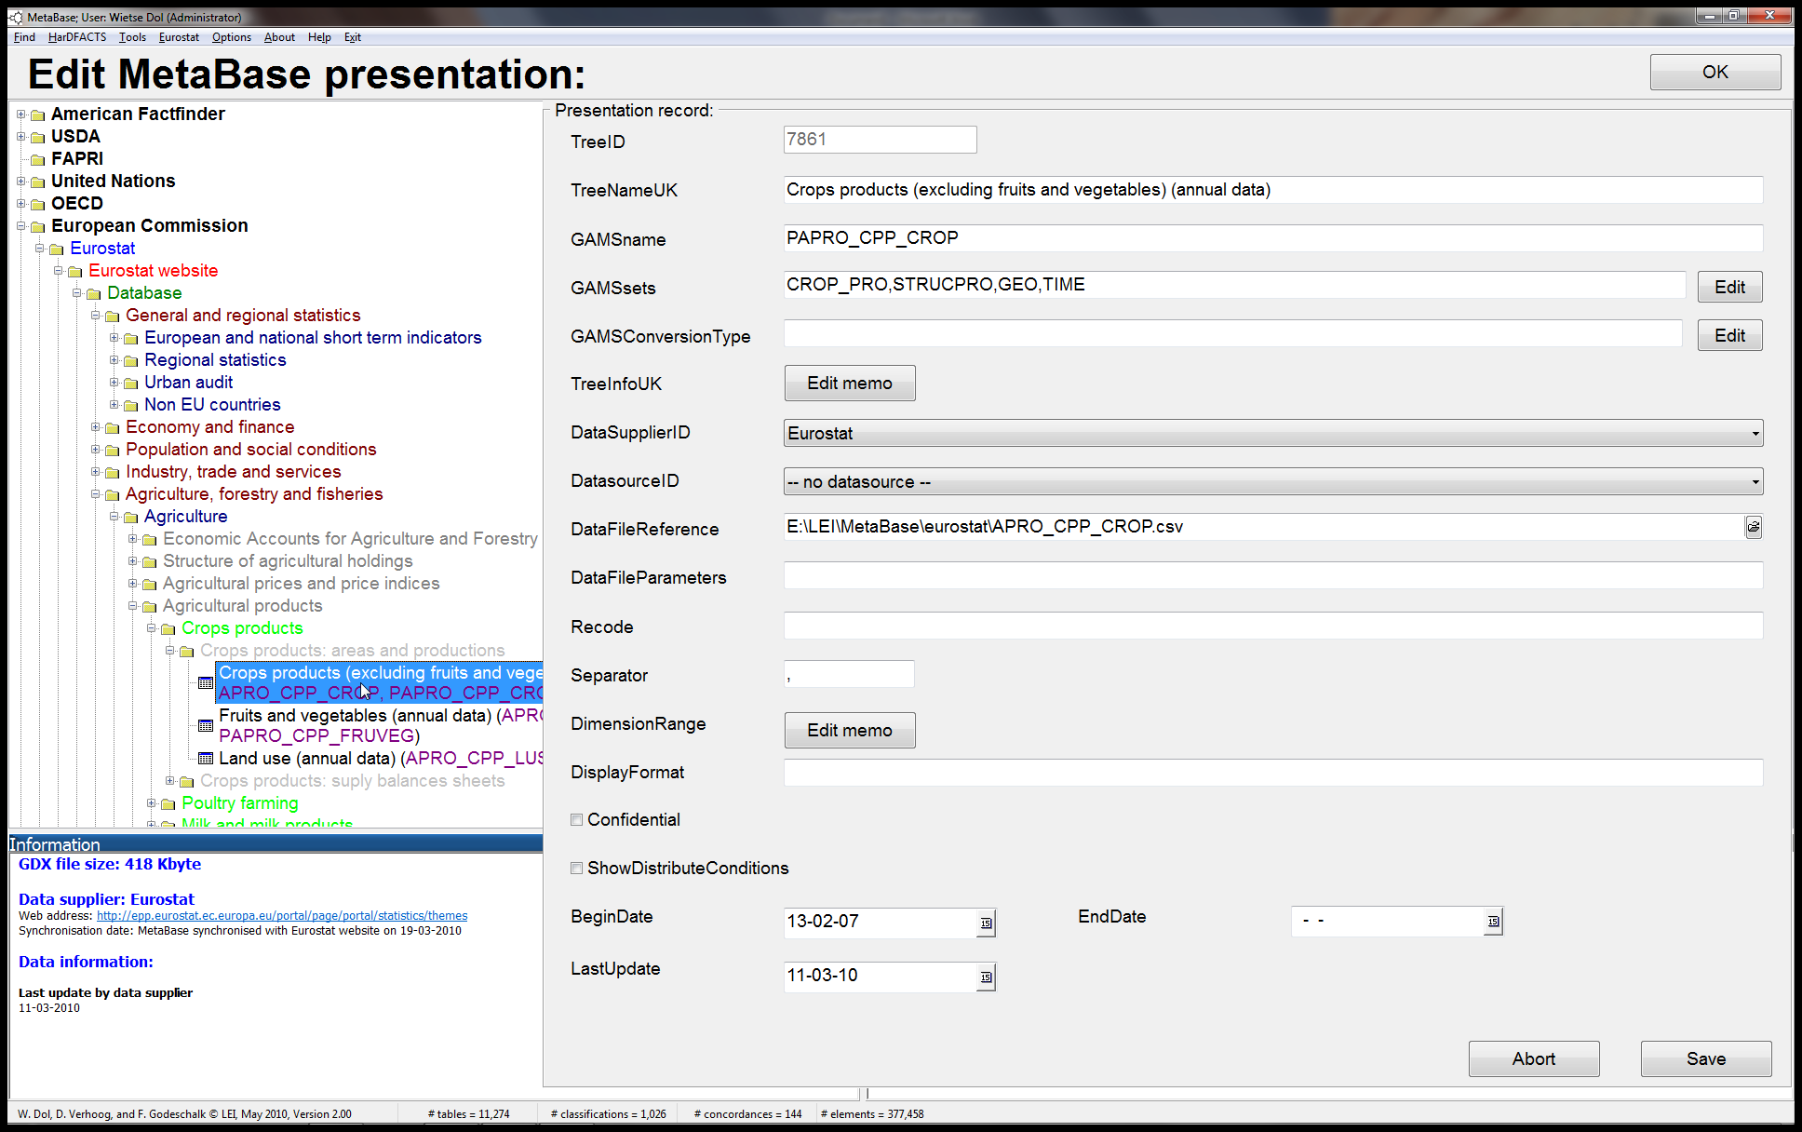
Entering the GAMSsets and GAMSconversionType is done by clicking on the “Edit” button and then in the window as shown below you select a new classification (and conversion) and press the “Add” button to add the (Time)Classification to the GAMSsets. The ordering of the GAMSsets can be changed by selecting a classification in “GAMS sets and GAMS conversion types” listbox and pressing the “Move up” or “Move down” button. By pressing the “Delete” button the selected classification in the listbox is deleted. To close the window press the “OK” button.
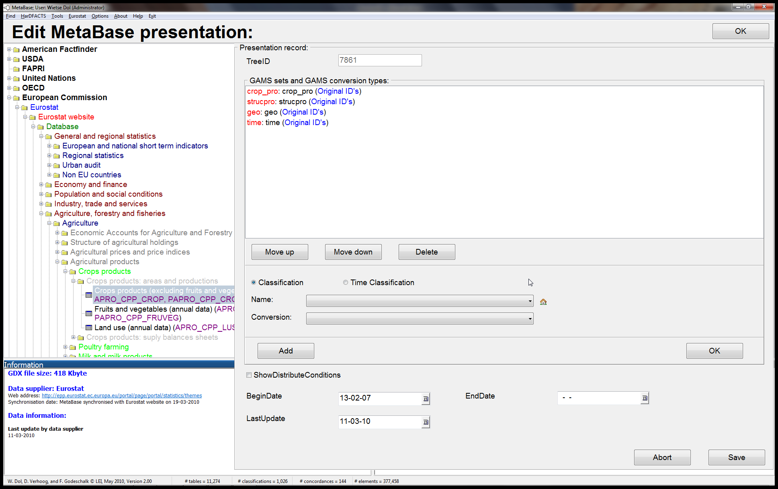
When you are ready editing/changing the presentation object press the “Save” button to save the changes. When you press the “Abort” button all made changes are ignored. When you are ready with modifying the Presentation tree you can press the “OK” button of the “Edit MetaBase presentation” window. First a copy of the current database is made (under the name metabase_backup.mdb). When you have changed the tree, changed objects and new objects are written to the Presentation table and the PresentationParentChild table is rewritten. Then MetaBase will restart and show the new tree.

Check for new/updated data:
In this window you can select a date and then all new and updated tables since the given date are shown in a tree (U stands for updated and N stands for new).
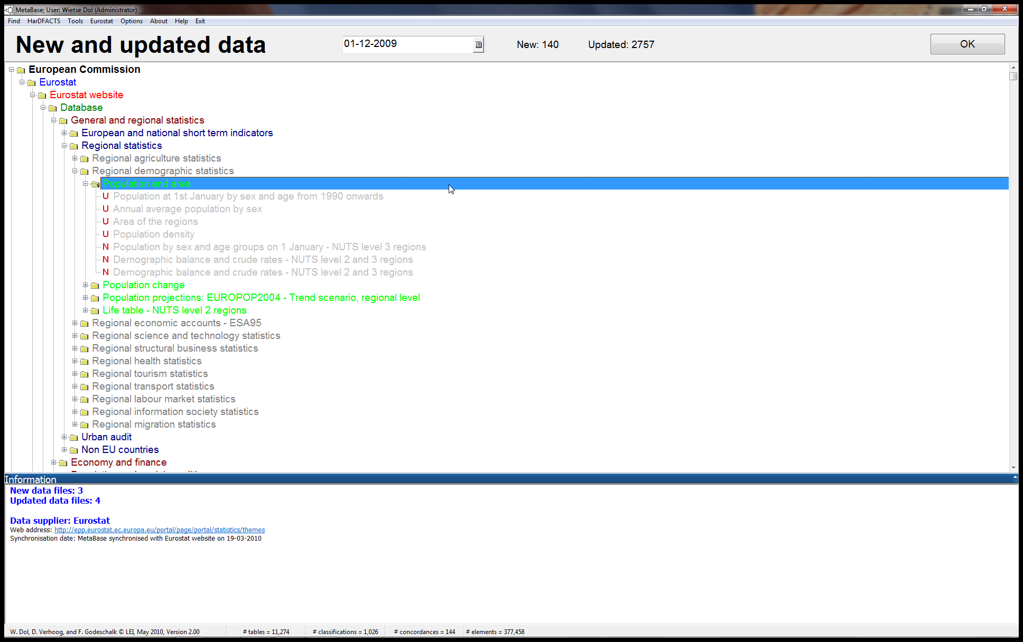

R
GAMS is an extremely useful tool for recoding and aggregating data and performing some data manipulation tasks. When you want to do matrix algebra or statistics the freeware program R is the preferred program. When you have a GDX file in MetaBase you can open it with the DataExplorer or the Data Selector to look at its contents. You can also use the generated GAMS code to do data manipulations… In version 2.0 of MetaBase it is possible to prepare the data and open it in R. Right click on your data file (“Data Viewer” tab sheet) and click on the option “Show R”.
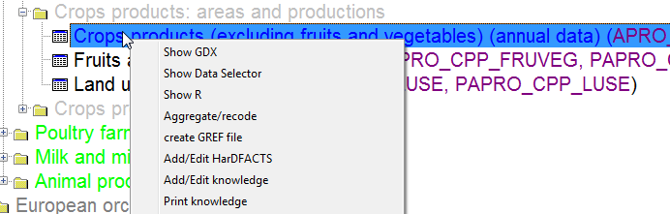

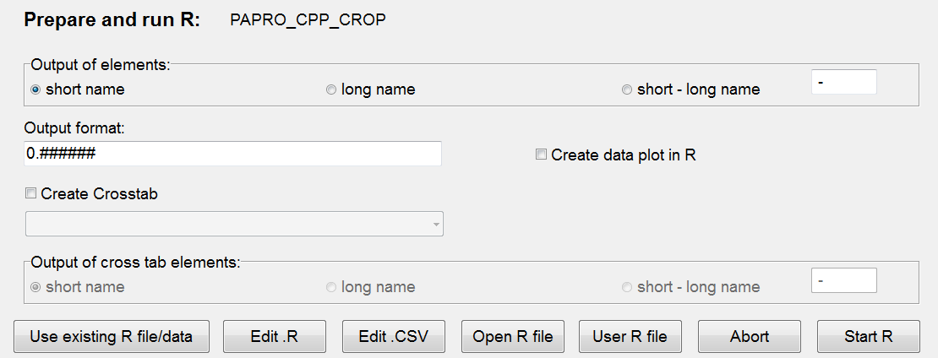
In this window you can select if the elements of the classifications used in the data are exported into R with the short name, the long name (description) or both. Also you can specify the output format of the data values. GDX data files are flat files (i.e. every data record consists of elements of the classifications and one data value) and in R you often like to use one of the classifications as columns/data frame (i.e. you like to create a crosstab of the flat data). Just check the “Create Crosstab” checkbox and then select the classification to be used as columns (see below where we have selected the years of the Eurostat data as the columns of the crosstab).
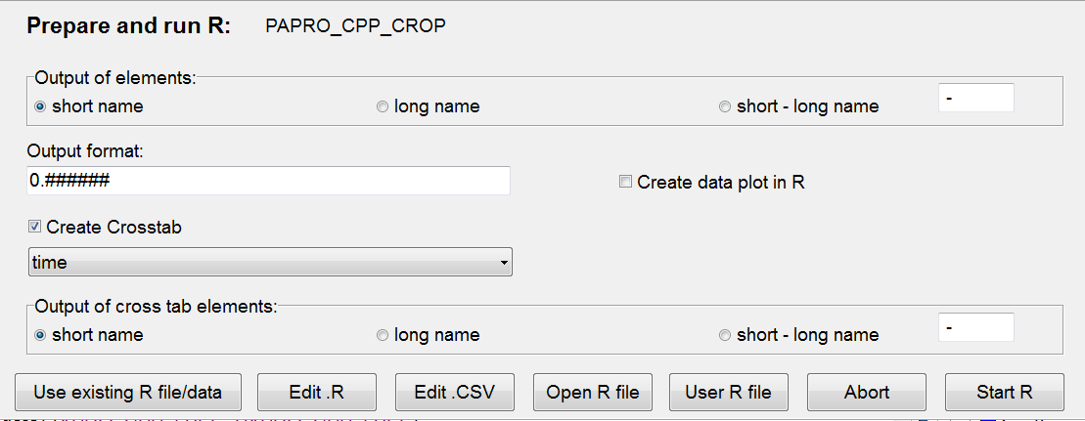
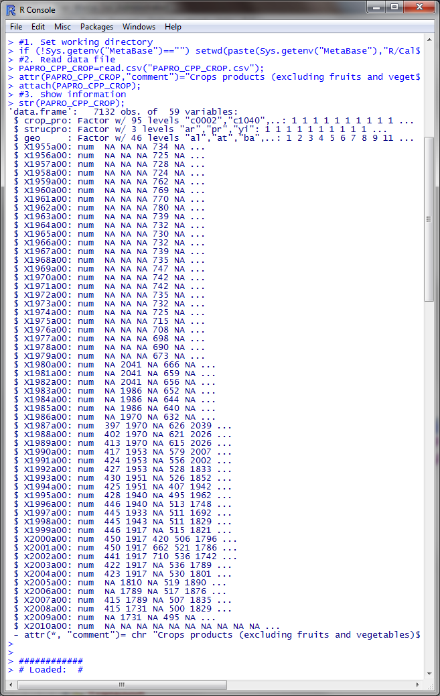
When you press the “Start” button, MetaBase will convert the GDX data into a CSV file and create R code to load the data (i.e. this is saved in the R\Calculations\ folder). Then it will start R and load and run the created code (using the MBtoR program) as well as the code you have created in your “User R file”. You can look/edit the R code by pressing the “Edit .R” button. If you want to see the content of the CSV file press the “Edit .CSV” button.

Options:
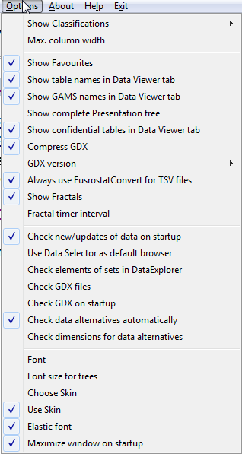
With the “Show Favorites” switch you can make your Favorites vissible or hide them.
The “Check new/updates of data on startup” options makes it possible that when you start MetaBase it will check if there are new/updated tables since the last time you used MetaBase. If there are new/changed data the “New and updated data” window is shown.
“Use Data Selector as default browser”: checking this will use the Data Selector instead of the Data Explorer as the default browser for GDX files.
“Check elements of sets in DataExplorer”: when the DataExplorer is started and loads a GDX file it will check if the elements in the GDX file are defined by the GREF file. If you uncheck this option this checking is skipped (saves time, but elements not defined in the GREF file aren’t displayed).

Starting MetaBase
metabase.exe username password /db=metabase.mdb /expand=2 /ADMIN
When you start MetaBase it will ask for a username and password. You can also start MetaBase with a username/password directly. Please put quotes around the username and password when it contains spaces! The /db option allows you to specify which database you want to use (i.e. it will override the database that is specified in your personal INI file). The /expand option will open MetaBase and expand/open the Presentation tree (the tree in the “Data Viewer” tab sheet) to the number of specified levels. The /ADMIN can be used to open a database in administrator mode (and hence make it possible to change the tree structure of the Presentation tree by using the “Edit Presentation tree” tool, discussed above).

